MCP 2551

Features:

- Supports 1 Mb/s operation
- Implements ISO-11898 standard physical layer requirements
- Suitable for 12V and 24V systems
- Externally-controlled slope for reduced RFI emissions
- Detection of ground fault (permanent dominant) on TXD input
- Power-on reset and voltage brown-out protection
- An unpowered node or brown-out event will not disturb the CAN bus
- Low current standby operation
- Protection against damage due to short-circuit conditions (positive or negative battery voltage)
- Protection against high-voltage transients
- Automatic thermal shutdown protection
- Up to 112 nodes can be connected
- High noise immunity due to differential bus implementation
- Temperature ranges:
- Industrial (I): -40°C to +85°C
  - Extended (E): -40°C to +125°C

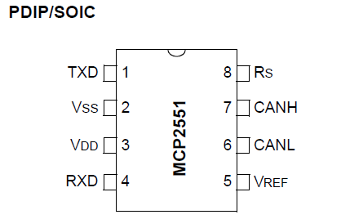

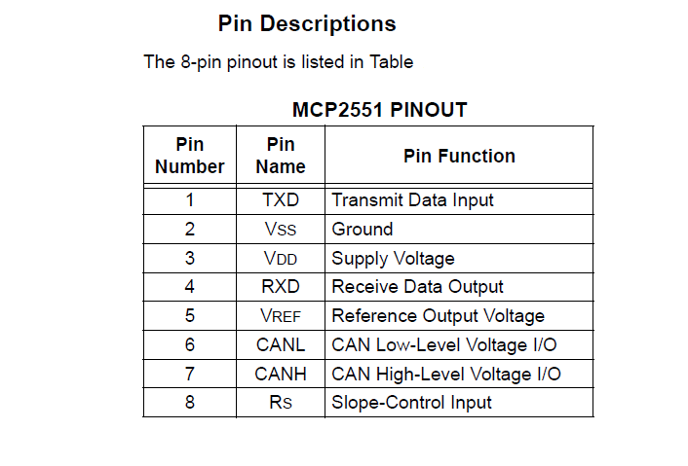
TRANSMITTER DATA INPUT (TXD):

TXD is a TTL-compatible input pin. The data on this pin is driven out on the CANH and CANL differential output pins. It is usually connected to the transmitter data output of the CAN controller device. When TXD is low, CANH and CANL are in the dominant state. When TXD is high, CANH and CANL are in the recessive state, provided that another CAN node is not driving the CAN bus with a dominant state. TXD has an internal pull-up resistor (nominal 25 k∧ to VDD).
GROUND SUPPLY (VSS):

Ground supply pin.
SUPPLY VOLTAGE (VDD):

Positive supply voltage pin.
RECEIVER DATA OUTPUT (RXD):

RXD is a CMOS-compatible output that drives high or low depending on the differential signals on the CANH and CANL pins and is usually connected to the receiver data input of the CAN controller device. RXD is high when the CAN bus is recessive and low in the dominant state.
REFERENCE VOLTAGE (VREF):

Reference Voltage Output (Defined as VDD/2).
CAN LOW (CANL):

The CANL output drives the low side of the CAN differential bus. This pin is also tied internally to the receive input comparator.
CAN HIGH (CANH):

The CANH output drives the high-side of the CAN differential bus. This pin is also tied internally to the receive input comparator.
SLOPE RESISTOR INPUT (RS):

The RS pin is used to select High-speed, Slope-control or Standby modes via an external biasing resistor.

